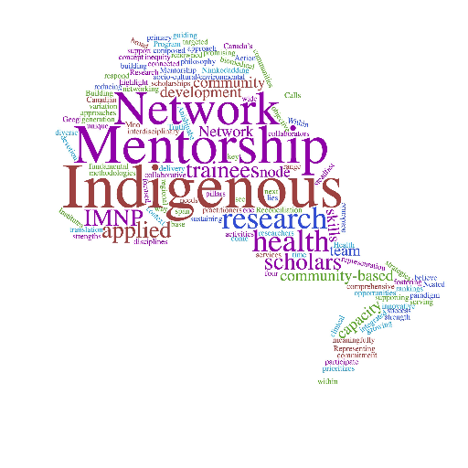
Indigenous Mentorship Network of Ontario

Graduate and Health Professional Scholarship (2025/2026)

Information for Applicants
The Indigenous Mentorship Network of Ontario (with funds from the Ontario NEIHR located at the University of Toronto) provides financial support for Indigenous graduate students (master’s or doctoral degrees) or health professional students (MD, OT, PT degrees) pursuing research in applied community-based Indigenous health and based at an Ontario institution. Financial support is provided in the form of scholarships.

Defining Health and Well-being
IMN-Ontario takes a broad definition of health and well-being. We understand that health and well-being derive from factors impacting the individual, family, community, and environment with historical experiences and contemporary political, social, and economic structures and environments all having a role in shaping health and well-being. If your research topic falls within this definition, it will be eligible for funding.

Scholarships
All scholarships/fellowships are considered for a one-year term. Applicants may re-apply for each year of their program; however, awards are limited to two years per degree. Students pursuing a Master’s, Doctoral, or Professional degree are eligible to receive up to $20,000 per year. The amount will be pro-rated at 50% for part-time students.
IMN-Ontario will award up to 5 scholarships in 2025/26. The CIHR scholarships will be paid by IMN-Ontario via McMaster University. Any other awards will be paid by the awarding institution and only students enrolled at that institution will be eligible, for example, only McMaster University students are eligible for the McMaster University Scholarship.

Graduate Level Scholarships Available from IMN-Ontario for 2024/2025 | Scholarship Amounts
CIHR Research Scholarships | $20,000.00 X 4
Western University Scholarship* | $20,000.00
ICES** | $20,000.00
Other institutional funding TBD
*Students must be enrolled at awarding institution to be eligible

**The ICES scholarship will be awarded to a student enrolled at any Ontario institution with interests in quantitative research and use of ICES data to support their research.

A student may hold another scholarship concurrently awarded by other major granting agencies, i.e., CIHR, SSHRC, NSERC, OGS. It is the student’s responsibility to consider how success in this funding opportunity may impact other sources of financial support.

Eligibility Criteria
In order to qualify for an IMN-Ontario scholarship:
- The applicant must self-identify as an Indigenous student.
- The applicant must be accepted by an accredited graduate or professional program in province of Ontario for the 2025-26 academic year. Proof of acceptance is not required at the time of application but is mandatory before any award funds can be released.
- The applicant must be undertaking or planning to undertake study in the area of community-based Indigenous health and well-being research.

Assessment Criteria
Reviewers will be assessing applications based on the following criteria:
Please ensure that these are explicitly addressed in the appropriate sections of your application.

Characteristics and Abilities of the Candidate
- Academic performance
- Research abilities
- Critical thinking
- Organizational skills
- Originality
- Independence
- Perseverance

Nature of the Proposed Research
- Fit with the focus of the IMN-Ontario greater objectives related to community-based Indigenous health and well-being research.
- Community-based approach to the research topic and project development.
- Indigenous community/organization involvement in and support for the research project.
- Quality and innovation of the proposed research.
Applicants will be evaluated based on their academic performance and potential to succeed in the program indicated. There must be a commitment to disseminate the information arising from the research, and an explicit statement identifying any ethical protocols that have been submitted or approved.
If an applicant has taken a longer than average length of time to complete their degree, please explain any interruptions or delays.

Other Relevant Application Information
The IMN-Ontario provides networking and training and mentoring activities, i.e., student gatherings and participation in webinars. Participation in IMN-Ontario training activities is expected of successful applicants. Successful applicants must agree to provide a short biography and a photo for the IMN-Ontario website at the time of notification of the award. Successful applicants will also complete a progress report near the end of their scholarship period which will be used for the IMN-Ontario for reporting and evaluation.
It is the applicant’s responsibility to obtain the required ethics approval for research involving humans from the relevant research ethics review board in their own institutions. Such approval is not required at the time of application but should be submitted to the IMN-Ontario as soon as it has been granted.
Application documents should be submitted online with transcripts and reference letters e-mailed to imn@mcmaster.ca or delivered to:
Indigenous Mentorship Network of Ontario c/o McMaster University
L.R. Wilson Hall, Suite 1811
1280 Main Street West Hamilton, Ontario, L8S 4K1
For more information, please contact:
imn@mcmaster.ca

Application deadline
All applications must be received by Monday March 31, 2025, at 4pm EST. No late applications will be accepted. All applicants will be notified of their result by mid-June.

Application Checklist
Please ensure that your application includes all of the following components:
- Completed applicant and program information on form.
- Completed project information section of form, including supervisor contact information.
- Uploaded summary of personal, academic and career goals (maximum one page).
- Uploaded summary of proposed research project (maximum 2 pages + 1 page bibliography).
- Uploaded copy of current CV.
- Uploaded letters of support from each Community Partner.
- Included community/organization name and name of contact person writing letters of support.
- Official transcript emailed or mailed/delivered to IMN-Ontario from most recent institution.
- Confirmed that Letter of Reference from academic supervisor sent directly to IMN-Ontario.
- Included name and institutional affiliation of academic supervisor on form.
- Confirmed that second Letter of Reference from an academic instructor or employer sent directly to IMN-Ontario.
- Included name and institutional affiliation or organization of academic instructor or employer on form.
- Completed other funding sources information section of form.
- Signed the applicant declaration and submitted application via IMN-O website.
These scholarships are made possible with financial support from the CIHR-funded Network Environments for Indigenous Health Research (NEIHR) – Ontario.
For more information on the Ontario NEIHR, please see their website by clicking here or scanning the QR Code on the next page.

We gratefully acknowledge that the institution-specific scholarships are funded by those institutions.

